Use-Case Realization Report
DeleteUserAdministrator

Issue <1.0>
Revision History
Date | Issue | Description | Author
<02/08/09> | <1.0> | <Delete User Administrator> | <Karen Gao>

Table of Contents
1. Brief Description 4
2. Flow of Events 4
2.1 Standard Flow 4
2.2 Exceptions 4
3. Interaction Diagrams 5
3.1 Collaboration Diagram for DeleteUserAdministrator 5
4. Participating Objects 5
5. Class Diagrams 6
5.1 Class Diagram for DeleteUserAdministrator 6
6. Derived Requirements 6

Use-Case Realization Report
DeleteUserAdministrator

Brief Description
The deletion of User Administrator shall be executed once the selection check for the existing User Admin list was performed.

Flow of Events

Standard Flow
This use case covers the events of deleting User Administrator, which is part of the User Administrator Maintenance package. The standard flow of events is described as below:
- The Portal Administrator shall press the button to send out a command of “deleteButtonClicked” on the interface of MaintainUserAdminPage.
- Once MaintainUserAdminController received this request, the operation checkUserAdminToDelete will check if there’s User Admin seleted.
- Then the operation getUserAdminList will get the User Admin list from object of UserAdmin.
- The operation deleteUserAdmin will delete the selected one from the list.
- The operation removeRole will remove the role from Customer object.
- Then the operation updateUserAdminList of the MaintainUserAdminController will update the new list of UserAdmin object
- Once it’s done, the successful updating userAdminList will show to the MaintainUserAdminPage.

Exceptions

- If there’s no selection found in User Admin records, a warning message will be show to the MaintainUserAdminPage through the operation showNoUserAdminSelectedMsg.

Interaction Diagrams

Collaboration Diagram for DeleteUserAdministrator
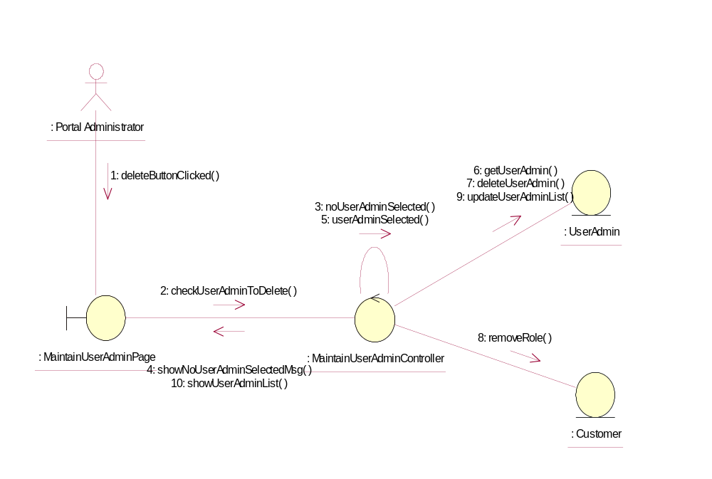

Participating Objects
: Customer
This Entity is Customer object

: MaintainUserAdminController
This controller is to add, delete and update User Administrator

: MaintainUserAdminPage
This is a page for adding, deleting, updating and displaying the User Administrator

: Portal Administrator
This is the super user of the system.

: UserAdmin
This Entity is UserAdmin Object

Class Diagrams

Class Diagram for DeleteUserAdministrator
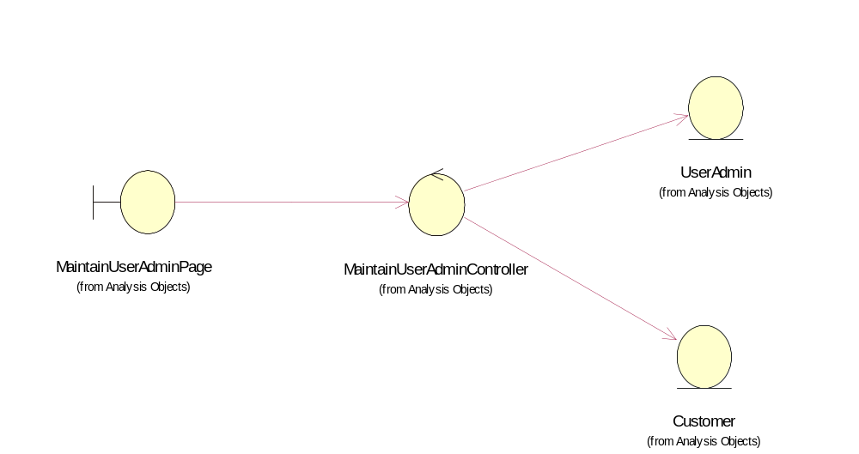

Derived Requirements
Only Portal Administrator has rights to access this page.

